A/B Testing

Table of Contents

Intro 2

When can you use AB Testing: 2

## Intro

* AB testing can help reach the peak of the mountain you are climbing but it cant tell if you sld be climbing this mountain or another
* AB testing cannot tell if something else missing in our experiment is actually a better option

When can you use AB Testing:  
**Clear control and metrics**

* **Control group**. Whether you can pick a control grp or not decides if AB testing can be done.   
  When a control group can be selected randomly with no complications.   
  Eg: Will a new premium service be successful? AB test?  
  It is not easy to pick a control grp that is willing to join premium service. Voluntary decision to join a premium service cannot be simulated and hence AB test is not of much help here
* **Time**:  
  The time taken to run the experiment to get meaningful results.  
  Eg: Can we test if a new feature in car selling website bring more customers?   
  It will be many years between two purchases for a car by same user hence AB testing is not applicable.
* **Major changes**:? No  
  AB testing is a not a good option when a major change or changes are made

What can be done when not applicable? Alternative techniques? Hybrid?

* Hypothesis testing
* Prescriptive analysis
* User research
* focus groups
* Surveys

Process flow of AB Testing in Business:

1. Define the User flow / customer funnel  
   a. visit website, select product, add to cart, make payment  
   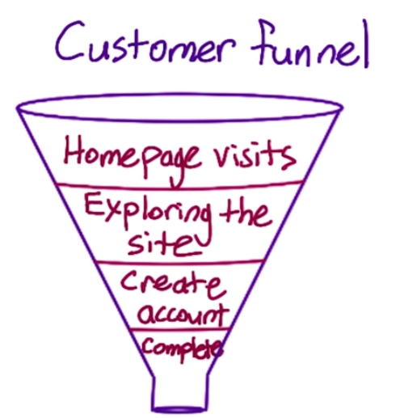
2. Hypothesis  
   Define hypothesis for experiment.  
   Cust. funnel is used and based on where the change is made. eg. change in homepage hence we zoom into the first two stages in customer funnel and see if number of customers going from top to next stage is affected